 Molar volume of a gas
Specification requirements
- C3.5 Use of amount of substance in relation to volumes of gases (Chemistry only) 
- MS 1a, 1c, 3b, 3c
- WS 1.2, 4.1, 2, 3, 4.6
Aims
In this practical, you will work out the volume occupied by 1 mole of carbon dioxide. The follow-up questions give you the opportunity to use gas volumes in calculations.
Learning outcomes
After completing this practical, you should be able to:
- know how to carry out an experiment to find the volume occupied by 1 mole of a gas
- calculate the molar volume of a gas from the experimental results
- calculate the volume of a gas at room temperature and pressure from its mass and relative formula mass
- calculate volumes of gaseous reactants and products from a balanced equation and a given volume of a gaseous reactant or product.
The student follow up questions give you the opportunity to use gas volumes in calculations.
Safety
- Wear eye protection at all times.
- 2 mol/dm3 hydrochloric acid: IRRITANT.
Equipment and materials
- 100 cm3 gas syringe
- delivery tube plus bung
- 2 d.p. balance
- weighing boat
- specimen tube
- boiling tube
- 2 mol/dm3 hydrochloric acid
- sodium hydrogencarbonate
Setting the scene
Equal numbers of moles of any gas occupy the same volume. The volume occupied by 1 mole is known as the molar volume. The aim of this experiment is to find the molar volume of carbon dioxide at room temperature and pressure.
You will add a known mass of sodium hydrogencarbonate to an excess of hydrochloric acid and collect the carbon dioxide produced in a gas syringe.
NaHCO3(s) + HCl(aq) → NaCl(aq) + H2O(l) + CO2(g)
By measuring its volume, you can work out the volume occupied by 1 mole
of CO2.
Method
1 Weigh accurately between 0.28 and 0.30 g of sodium hydrogencarbonate and transfer it to a boiling tube. Record the exact mass.
2 Fill a specimen tube with the 2 mol /dm3 hydrochloric acid.
3 Set up the apparatus as shown in the diagram, making sure you lower the specimen tube carefully into the boiling tube.
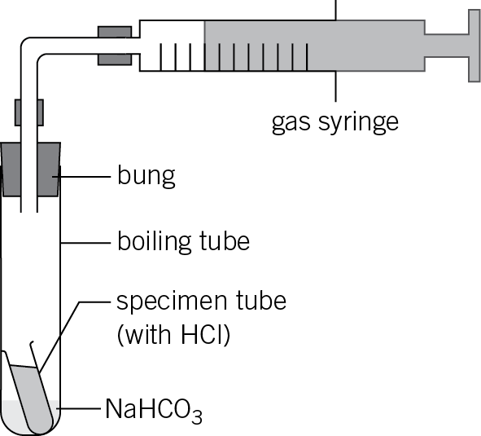
4 Tip the apparatus slightly to allow the acid to react with the sodium hydrogencarbonate.
5 When the reaction has finished, record the volume of gas produced.
Results
Record the following measurements:
mass of sodium hydrogencarbonate used =
volume of carbon dioxide produced =
Questions
1 Work out the Mr of NaHCO3.

(1 mark)
2 Use the mass to calculate the number of moles of sodium hydrogen carbonate.

(1 mark)
3 Use the chemical equation to find the number of moles of carbon dioxide produced.

(1 mark)
4 Complete the following sentences:
moles of CO2 occupies cm3
So, 1 mole of CO2 occupies cm3 at room temperature and pressure.
(2 marks)
5 What is the molar volume of CO2 in dm3? Give your answer to 3 significant figures.
(2 marks)
6 The volume of 1 mole of any gas is 24 dm3 (24 000 cm3) at room temperature and pressure, that is, at 20 °C and 1 atmosphere pressure. How close is your value to this?
(1 mark)
7 Suggest two reasons why your experimental value is different from the accepted value.

(2 marks)
8 Suggest two additional errors that would have occurred if the carbon dioxide had been collected over water using the apparatus shown in the diagram below.

(2 marks)
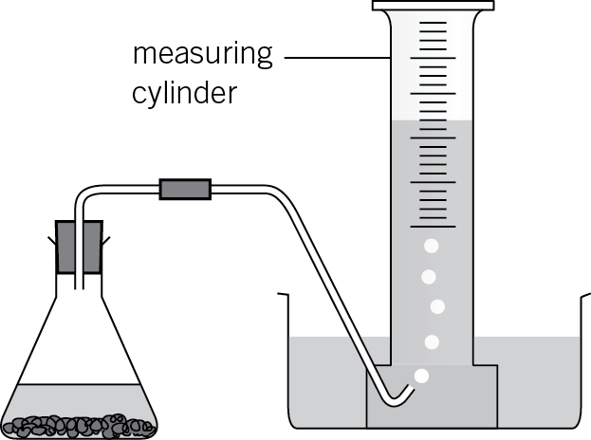
Student follow up
You will need to use the following expressions for these calculations:
Number of moles of any substance = 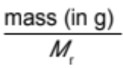
Number of moles of a gas = 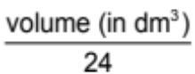
You also need to know that 1 dm3 = 1000 cm3 and the molar volume of a gas is
24 dm3 (or 24 000 cm3) at room temperature and pressure.
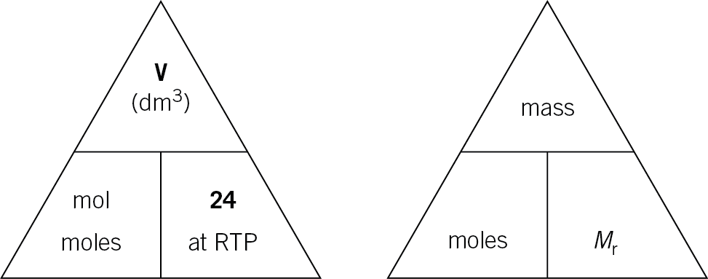
1 Calculate the number of moles in:
a 48 dm3 of H2

(1 mark)
b 1.2 dm3 of N2

(1 mark)
c 36 cm3 of CH4.

(1 mark)
2 Calculate the volume (in dm3) of:
a 880 g of CO2

(2 marks)
b 4 g of CH4

(2 marks)
c 284 g of Cl2.

(2 marks)
3 When propane burns in air, carbon dioxide and water are produced.
C3H8(g) + 5O2(g) → 3CO2(g) + 4H2O(l)
a Calculate the volume of CO2 produced when 20 dm3 of propane is burnt.

(2 marks)
b What volume of oxygen will be required?

(2 marks)
4 When nitrogen reacts with hydrogen, ammonia is produced:
N2(g) + 3H2(g) → 2NH3(g)
a Calculate the volume of NH3 produced when 50 dm3 of nitrogen is used.

(2 marks)
b What volume of hydrogen will be required?

(2 marks)
5 When calcium carbonate is heated strongly, calcium oxide and carbon dioxide are produced:
CaCO3(s) → CaO(s) + CO2(g)
Calculate the volume of CO2 (measured at room temperature and pressure) produced when 500 g of calcium carbonate is heated.
(Ar values: Ca = 40, C = 12, O = 16)

(4 marks)
6 When heptane (one of the main constituents of petrol) burns in air the following reaction occurs:
C7H16(l) + 11O2(g) → 7CO2(l) + 8H2O(l)
Calculate the volume of CO2 (measured at room temperature and pressure) produced when 2500 g of heptane is burnt.
(Ar values: H = 1, C = 12, O = 16)

(4 marks)

